Exercises: Unit Testing Methods
Submit your solutions here: https://judge.softuni.org/Contests/4682/Unit-Testing-Methods-Exercise

Unit Test Method: Fibonacci
Look at the provided skeleton and examine the Fibonacci.cs class that you will test: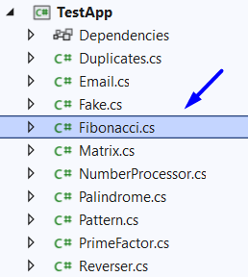
The method takes in an integer , and calculates the Fibonacci number:
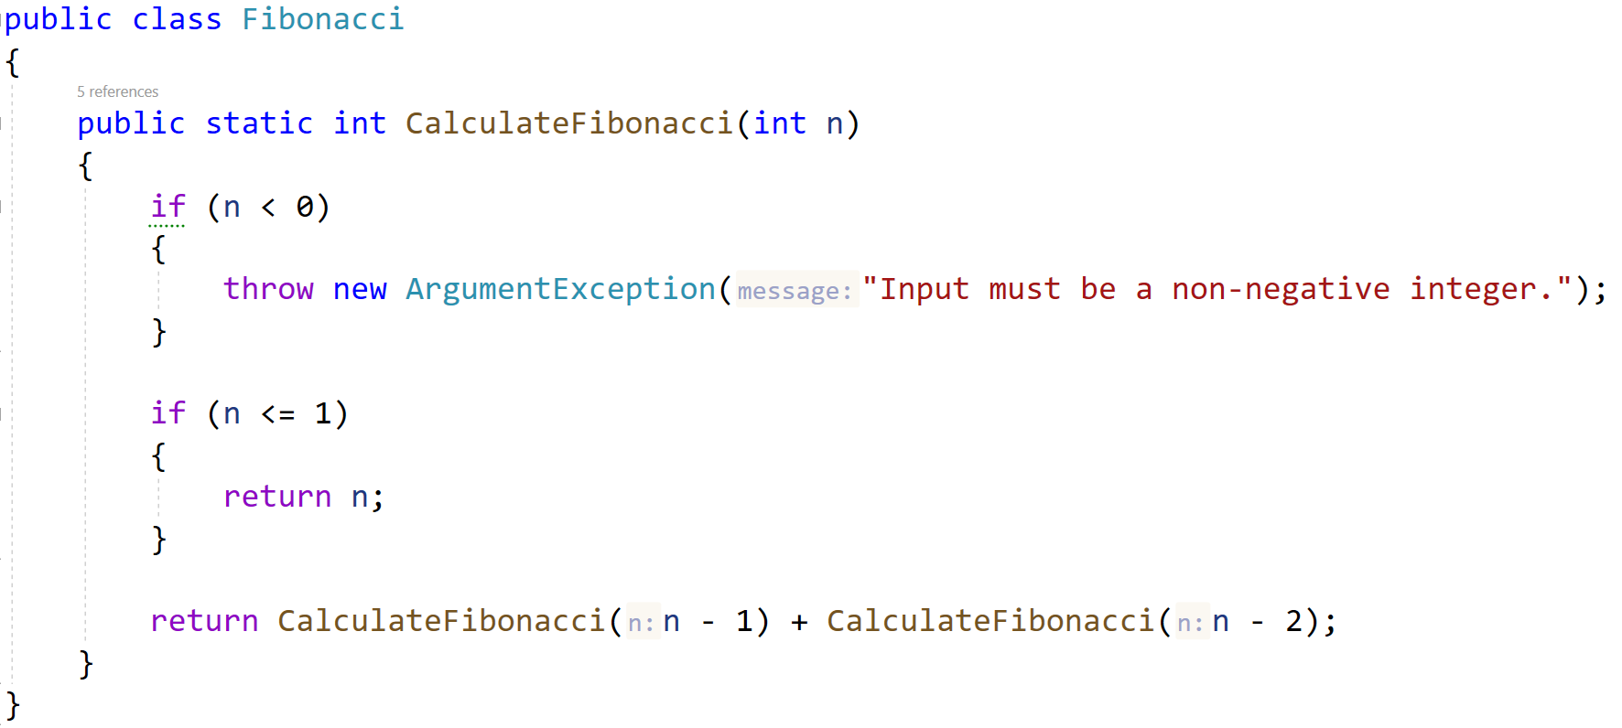
Then, look at the tests inside the FibonacciTests.cs class:
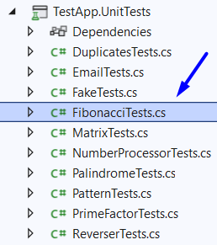
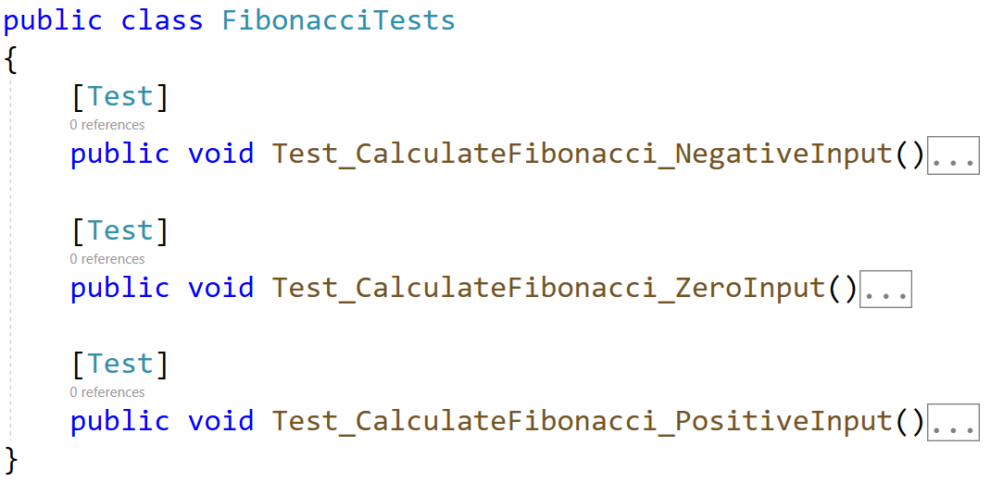
The first test if finished so you have a reference, the rest of the tests are empty, and your task is to finish them. The tests should run when you're finished:
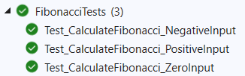

Unit Test Method: Email
Test a given method which takes in a string representing an email address and finds if the given email is indeed a valid email or not.
The method is found in the Email.cs file:
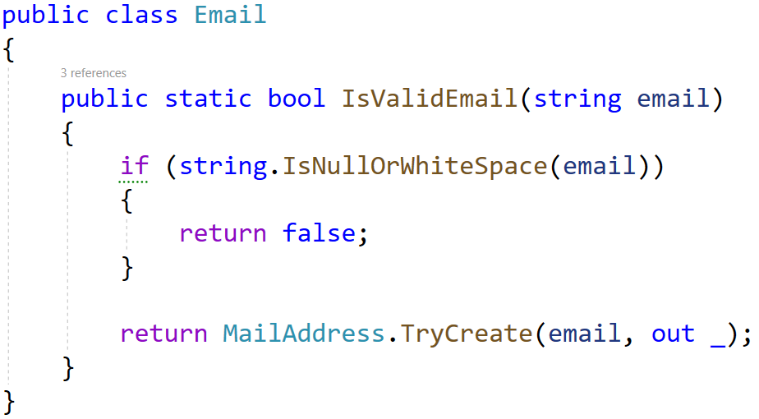
You are given again a test file EmailTests.cs which contains 3 tests. One of them has been finished partially, and two are empty for you to finish:
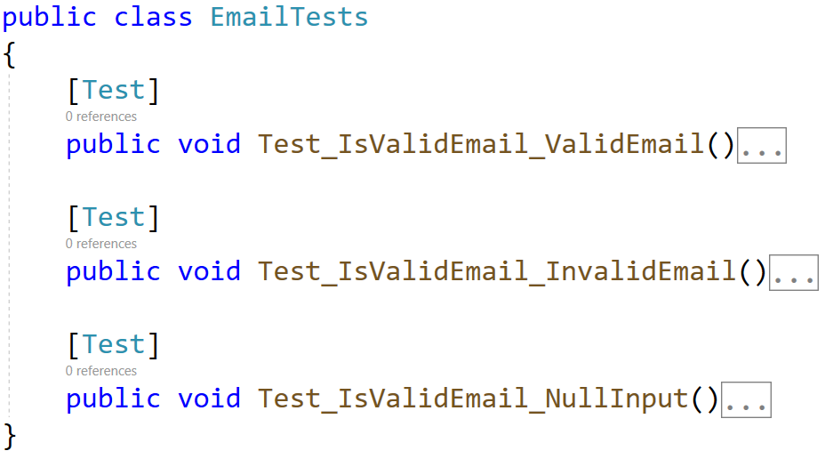
When you are ready make sure your tests run:
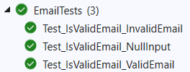

Unit Test Method: Prime Factor
Test a given method which takes in a long number and finds the largest prime factor of the given number.
The method is found in the PrimeFactor.cs file:
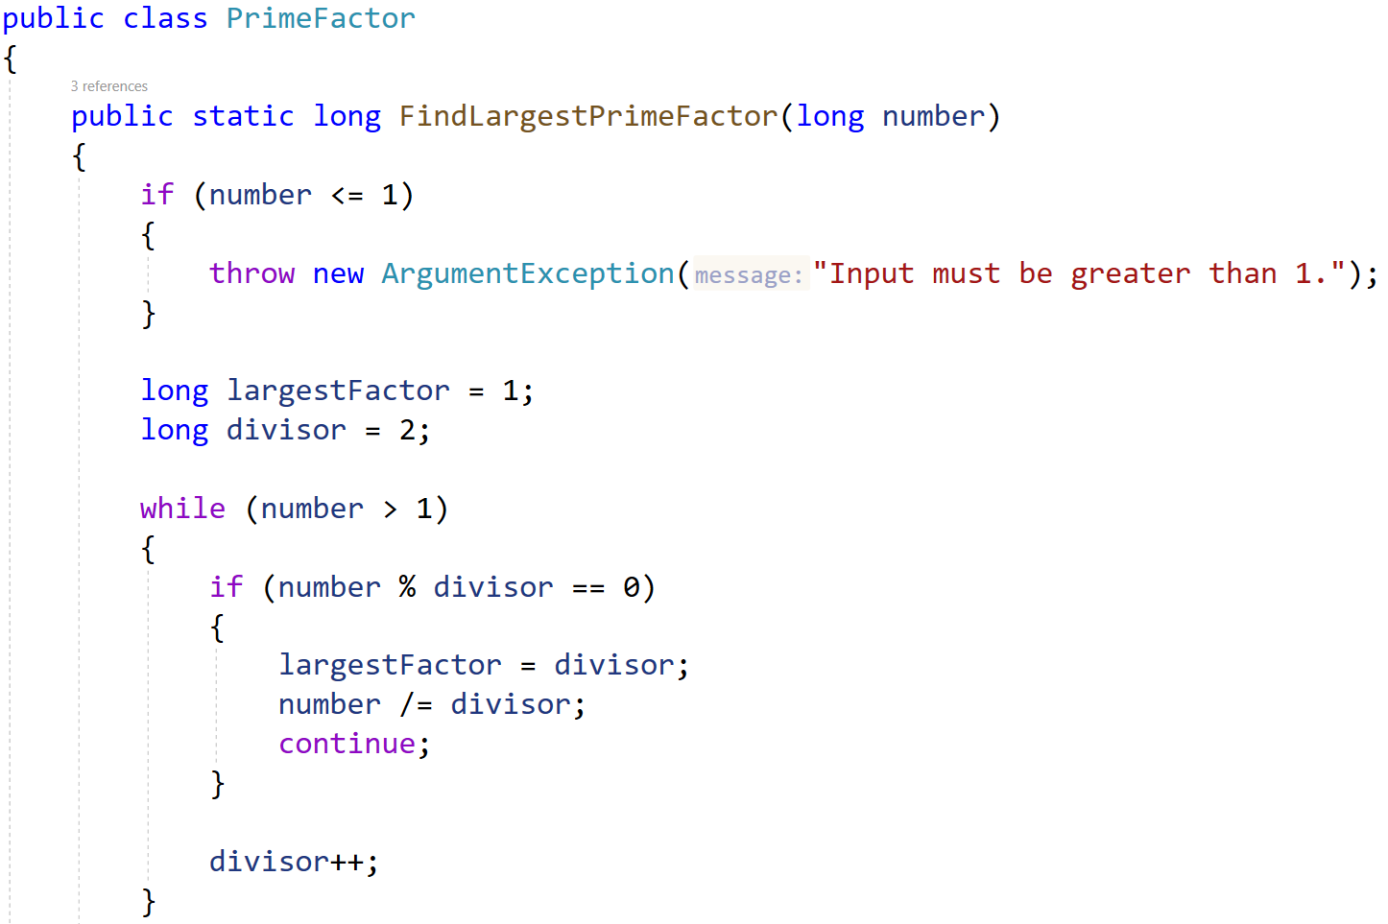
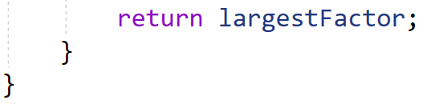
In the test file PrimeFactorTests.cs you are given 3 empty tests. Finish them and run them:
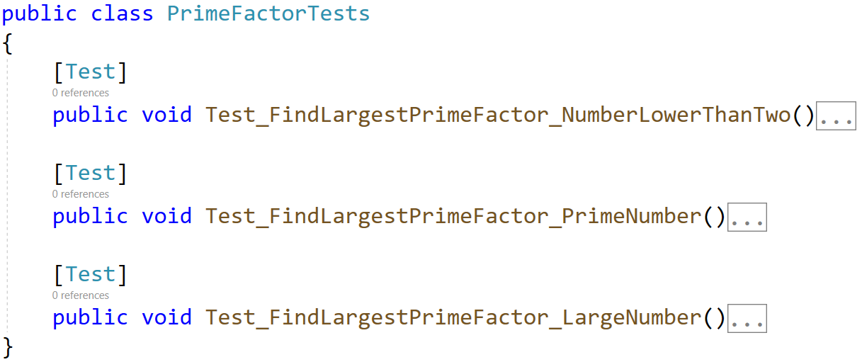

Unit Test Method: Sign of Integer Number
Test a method that takes in a string, parse it to integer and checks if the given number is positive, negative, or zero. The method returns the following string as result:
- For positive number: "The number {number} is positive."
- For negative number: "The number {number} is negative."
- For zero number: "The number {number} is zero."
- If not an integer: "The input is not an integer!"
The method is found in the SignOfIntegerNumbers.cs file:
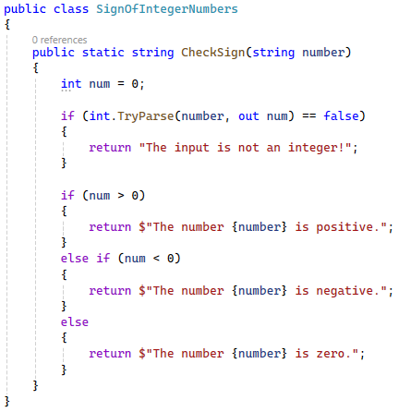
You are given a test file SignOfIntegerNumbersTests.cs containing 4 empty tests:
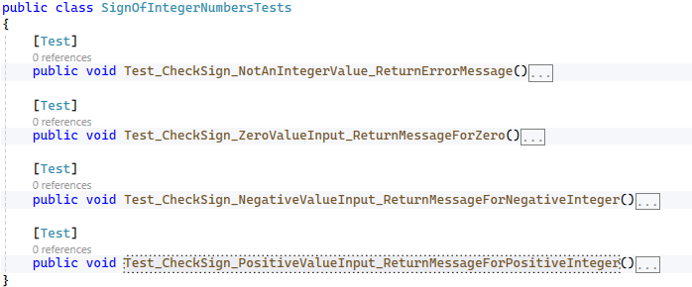

When you are ready make sure your tests run:
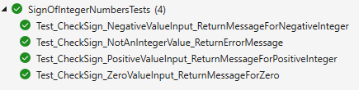

Unit Test Method: Average Grade Definition
Test a method that takes in list of double values, calculate the average and returns the corresponding grade definition as string:
- 2.00 – 2.99 - "Fail"
- 3.00 – 3.49 - "Poor"
- 3.50 – 4.49 - "Good"
- 4.50 – 5.49 - "Very good"
- 6.00 - "Excellent"
The method is found in the AverageGrade.cs file:
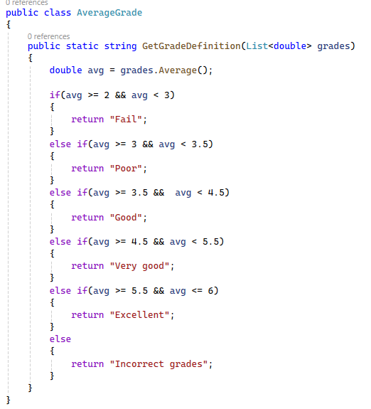
You are given a test file AverageGradeTests.cs containing 7 empty tests:
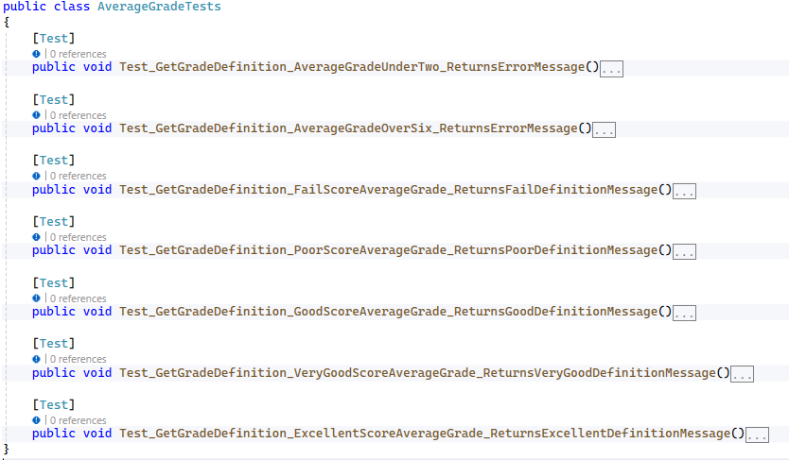
When you are ready make sure your tests run:
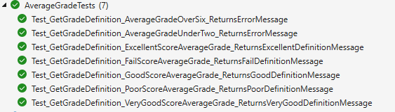

Unit Test Method: Middle Characters
Test a method that takes in a single string and returns a string with the middle character of the input. If the length of the string is even, there are two middle characters.
The method is found in the MiddleCharacters.cs file:
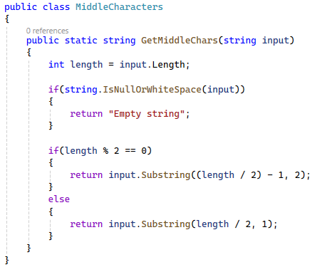
You are given a test file MiddleCharactersTests.cs containing 5 empty tests:
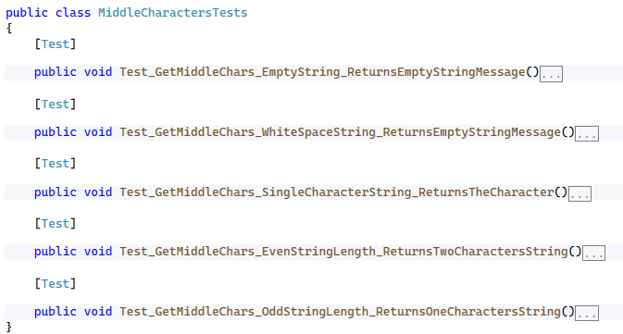
When you are ready make sure your tests run:
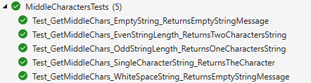

Unit Test Method: Palindrome Integers
Test a method that takes in a list of integers and returns a list of palindrome integers. A palindrome is a number that reads the same backward as forward, such as 323 or 1001.
Note: The method is not static. You need to call it in a different way.
The method is found in the PalindromeIntegers.cs file:
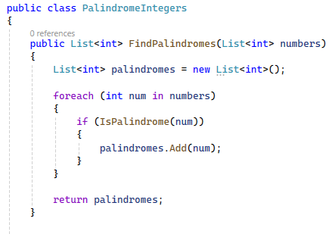
There is one helper method to find if the integer is palindrome:
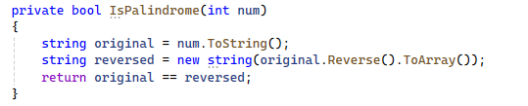
You are given a test file PalindromeIntegersTests.cs containing 5 empty tests:
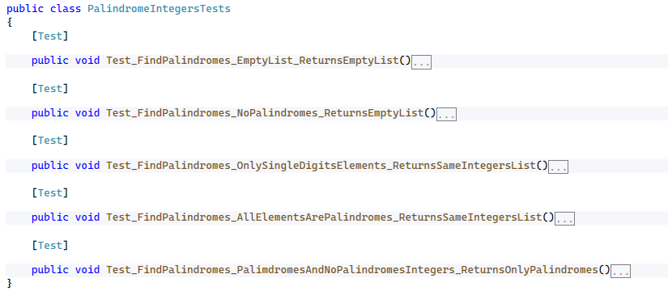
When you are ready make sure your tests run:
